CO5 ASSESSMENT TOOL-1

Q24. Feedback Vertex Set Problem (NP-Complete Problem)
Aim
To find the minimum set of vertices whose removal makes a given graph acyclic (cycle-free) using a backtracking approach with pruning techniques, and to analyze the correctness and NP-Complete nature of the Feedback Vertex Set Problem.
Algorithm
Input
A graph $G(V,E)$
Output
Minimum Feedback Vertex Set (FVS)
Steps
- Start with graph $G(V,E)$.
- Check whether the graph contains any cycle.
- If no cycle exists:
  - Return the current set of removed vertices as a feasible solution.
- If a cycle exists:
  - Select a vertex from the detected cycle.
  - Remove the selected vertex.
  - Add it to the feedback vertex set.
  - Recursively solve the remaining graph.
- Apply pruning:
  - If the current solution size is greater than or equal to the best solution found so far, stop exploring that branch.
  - Ignore branches that cannot improve the current best result.
- Continue until all possibilities are explored.
- Return the smallest feedback vertex set found.

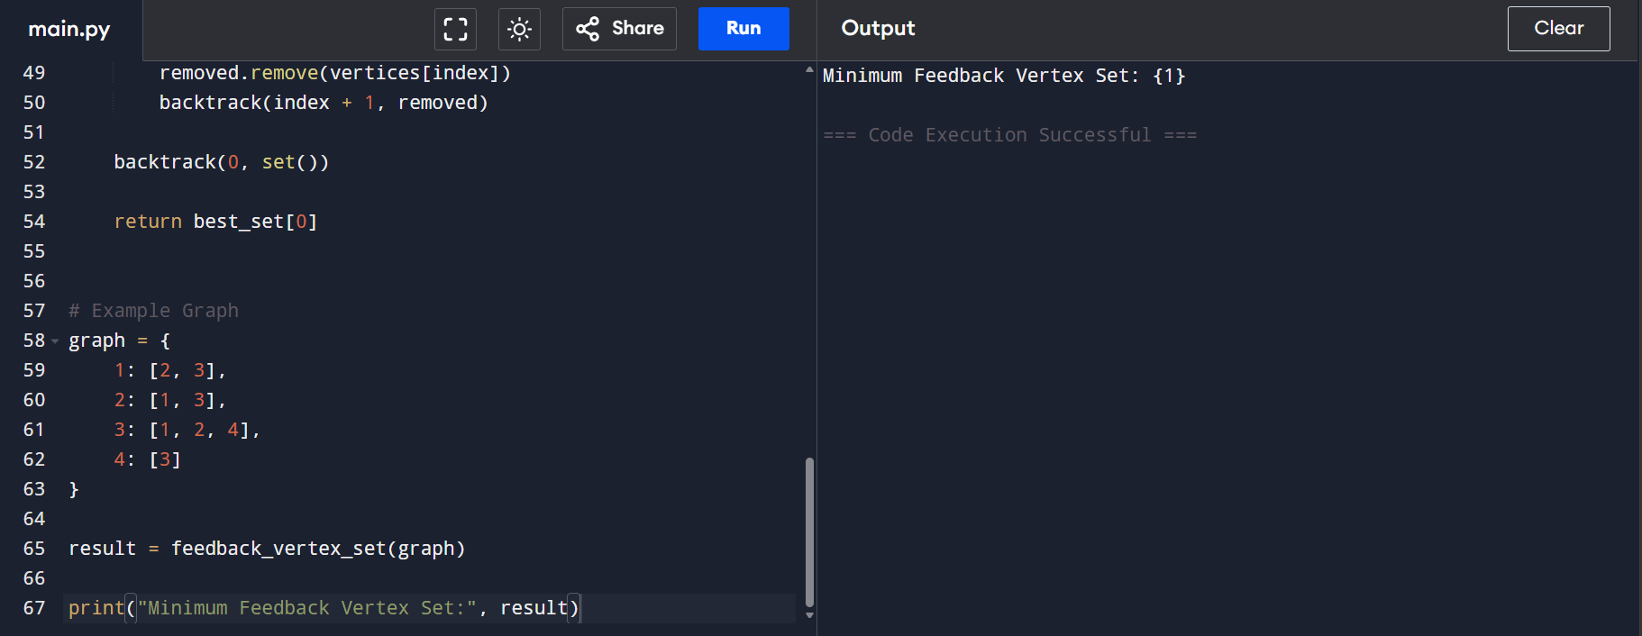
Output
Minimum Feedback Vertex Set = {A}
Size = 1
Time Complexity
- Worst Case: O(2^V)
- Due to exploring subsets of vertices through backtracking.
Space Complexity
- O(V) (recursion stack)
Q74. Minimum Path Cover Problem (NP-Complete Problem)
Aim
To find the minimum number of paths required to cover all vertices in a graph while satisfying vertex coverage and path disjointness constraints using a backtracking approach with pruning techniques.
Algorithm
Input
A graph $G(V,E)$
Output
Minimum Path Cover (MPC)
Steps
- Start with graph $G(V,E)$.
- Initialize an empty set of paths.
- Select an uncovered vertex.
- Extend a path from the selected vertex using available edges.
- Mark all vertices in the path as covered.
- Recursively cover remaining uncovered vertices.
- Apply pruning:
  - If the current number of paths is greater than or equal to the best solution found, stop exploring that branch.
- Continue until all vertices are covered.
- Return the solution with the minimum number of paths.

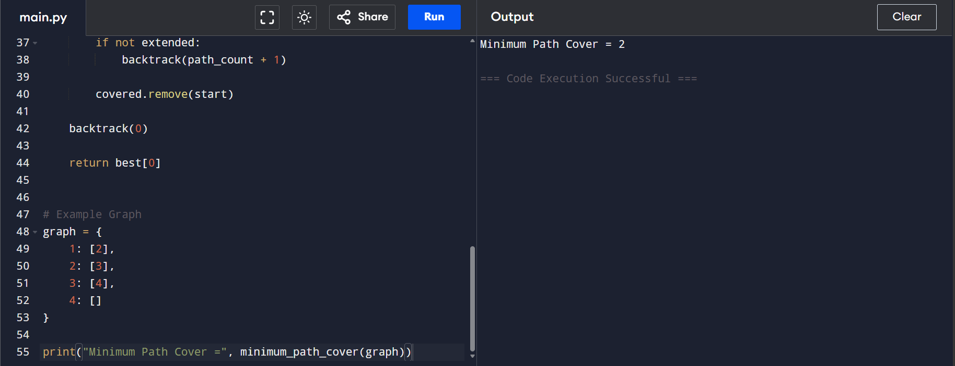
Output
Minimum Path Cover =
{A→B→C, D→E}
Number of Paths = 2
Time Complexity
Worst Case: O(2^V)
(Backtracking explores many possible path combinations.)
Space Complexity
O(V)
(Recursion stack and coverage tracking.)

